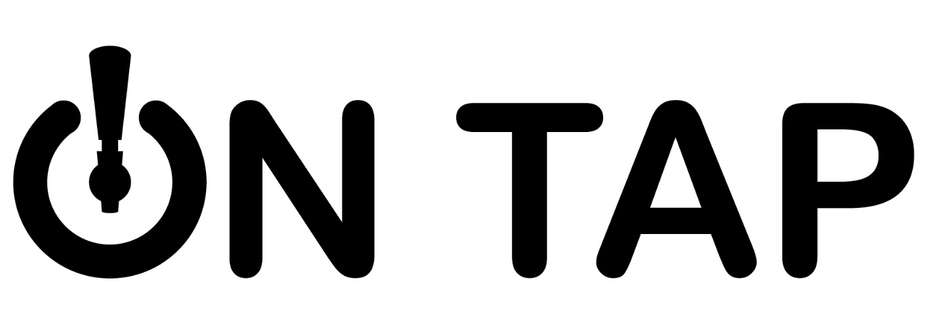
CHILI COOK OFF RULES AND APPLICATION Cooking Rules:
Single entry or teams welcome, there is a team maximum of 5 people. Set up location will be on a first come basis. Contestants must furnish their own ingredients, equipment, utensils and fuel. All contestants are responsible for maintenance of the chili’s proper temperature for serving. On Tap will provide spoons, cups and napkins for serving to the general public. Chili may be prepared outdoors at the site or brought already cooked to the site.
People’s Choice Judging:
1st, 2nd and 3rd place awards will be given to the overall winners. A People’s Choice award will be decided by the general public voting. The entry fee is $15 per chili entered. Contestants may enter more than one type of chili. Tasting Noon-3PM. Tabulation will be at 3PM and winners announced!

Ingredients:
Use your favorite recipe, with or without meat, with or without beans. Meat may be beef, pork, lamb, chicken, turkey or venison. Vegetarian chili is also acceptable. Ingredients may be cut, shredded or ground to any size. Pre-cooked beans are okay.

Chili Rules:
Each contestant must cook a minimum of 6 quarts of chili. Each contestant or team will be given a contestant number. Your number will be visible to the public. The voters receive a ticket to drop off into their choice of best chili. The more people you know the better chance you have of winning!

Chili Cook Off Schedule:
Set Up: 11AM-Chili must be hot and ready to serve at NOON. NO LATE ENTRIES Bring your chili and set up your table. You may decorate your table however you feel. You are welcome to promote your business.

CHILI COOK OFF REGISTRATION FORM

Saturday, December 7th, 2019

On Tap, 200 N. Mesquite, Suite 105

Arlington, TX 76011
Return this form along with your $15 entry fee to On Tap, 200 N. Mesquite, Suite 105. Arlington, TX 76011. All participants must pre-register.
Name: ____________________________________________________
Team Name: _______________________________________________
Chili Name: ________________________________________________
Phone Number: _____________________________________________
Address: ___________________________________________________
City: ________________________________ State: ______ Zip: _______
Email Address: ______________________________________________
Memorandum of Agreement: I certify that I have received a copy of the official rules and that I agree to abide by them. I understand any violation may disqualify my team from competition and prizes/awards.

Signature: ________________________________________________
Printed Name: _____________________________________________

